Transfer Guide
RN-BSN Completion Transfer Guide
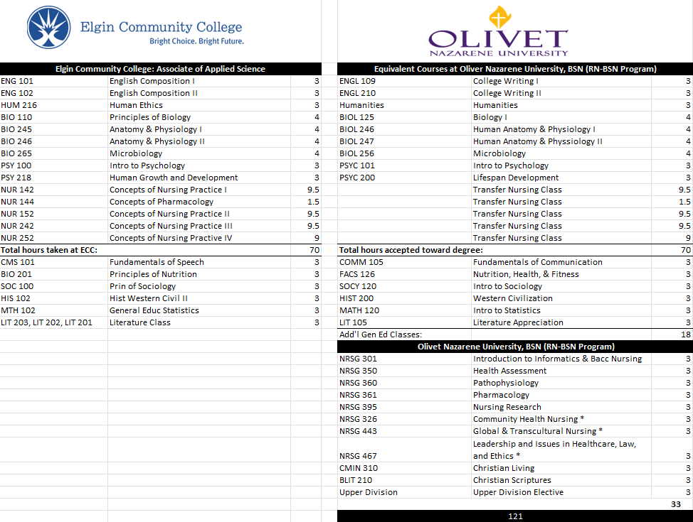
The following is presented as a transfer guide between Elgin Community College (ECC) and Olivet Nazarene University (ONU) for the Registered Nurse degree program based on the current catalogs of both schools. The student would receive an Associate of Applied Science (RN-AAS) degree from ECC and a Bachelor of Science (BSN) degree in Nursing from ONU.

Olivet Nazarene University, located at 1 University Avenue, Bourbonnais, IL 60914 and Elgin Community College believe that cooperative programs benefit the community, employers, and students in their regions. It allows a smooth transition for students transferring between institutions and maximizes allowable transfer of credit. Therefore, Olivet Nazarene University (ONU) and Elgin Community College (ECC) are entering into the following agreement for articulation:

Olivet Nazarene University agrees that if a student satisfactorily completes the Associate of Applied Science Nursing degree with a minimum 2.75 GPA and presents the appropriate transcript documentation of such to the Registrar of Olivet Nazarene University, the student will receive full recognition of that degree toward the completion of the Bachelor of Science in Nursing (BSN) at Olivet Nazarene University.
Program Overview
The RN-BSN is a degree completion program that develops leadership skills to navigate the dynamic health care environment. This program integrates previous nursing experience and knowledge into the academic course work with the intention of applying the skills developed to the work environment and enhance nursing practice. There are no exams in this program and 45 hours of practicum experience spread over three courses. The practicum hours focus on community education, leadership problem solving, and the nurse as a change agent.
*Represent 15 practicum hours required in class.
Course Transfer Guidelines
All coursework is accepted in transfer; however, only courses with a grade of “C” or better will meet program requirements. ONU transfers in coursework with a D- or better but C- or below does not meet the grade requirement for nursing. Admission to the RN-BSN program requires a copy of RN license, transcripts from previous college(s), cumulative GPA of 2.75 or better. Graduation requirements include successful completion of the BSN curriculum and practicum hours, a GPA of 2.75 or above and a minimum of 120 semester hours of college credit, which will include required general education and elective courses for the bachelor’s degree. Practicum requirements include successful completion of a certified background check and drug screening prior to starting practicum hours. The BSN degree is awarded after successful completion of the BSN curriculum and practicum hours. **Students who have completed an associate degree or diploma program in nursing may substitute a biological science in place of CHM-101 to fulfill general education requirements as a required supporting course.

Delivery Format
ONU courses are offered to students at the following locations:
• Fully Online
• 8-week courses for Nursing Core
• 8-week courses for General Education
• Personal Learning Plan

Olivet Nazarene University
Graduate and Continuing Studies
1 University Ave, Bourbonnais, IL
(877) 4-Olivet or (877) 465-3838
onlineadmissions@olivet.edu

Olivet Nazarene University Representative
Tiffany Holohan
Director of Community College and Academic Partnerships
tmholohan@olivet.edu
815-928-5515
Elgin Community College Representative
Tracy Vittone
Director of Transfer Services
tvittone@elgin.edu
847-214-7548
Disclaimer
This is a guide for students who plan to transfer to Olivet Nazarene University. This guide is not intended to be a contract with ONU. The information on this guide is subject to change. Students should contact their community college or ONU to keep informed of changes. Final responsibility for verifying all transfer information lies with the student. Please refer to the effective and/or revised date on the bottom of this guide.

